Questionnaire for the self-assessment of the hospital/health facilityfor the MAA Programme

- Basic Information

1. Name and address of the health facility:
2. Name and designation of the administrator of the facility:
3. Type of the hospital (tick all that apply): * General Hospital *Maternity Hospital *Teaching Hospital *
Private Hospital * Government Hospital
4. Number of staff members in the maternity and newborn services: Doctors _____ Nurses ____
5. Number of dedicated breastfeeding counsellors providing counselling services to the pregnant and
lactating women in your facility ___________
6. Number of women attending the antenatal clinic in the hospital in last one months: ____________
7. Number of deliveries in the facility during last one month: Total ____ Vaginal___ Caesarean with GA
Caesarean without GA
8. Number of newborn babies who were admitted to the neonatal unit during last one month:
9. Number of infants discharged from the facility in last three months: Out of them:
a. Initiated breastfeeding within one hour of birth %
b. Discharged with exclusive breastfeeding %
c. Received feeds other than breastmilk %

- Questions

S.  No. | Question | Response
1. | What activities are being implemented in your facility under the MAA programme?
2. | Does your hospital have a written guideline for the 10 steps to  successful breastfeeding? | Yes/No
3. | What proportion of staff working in the maternity and new-born services in the facility is trained in skilled counselling on breastfeeding under  the MAA programme? | - Doctors ______ (%) Nurses (%)  - Duration of the training: Doctors_____days;Nurses days
4. | Does your facility have an ongoing  monitoring and data-management | Yes/No

system on early initiation of breastfeeding and exclusive
breastfeeding at discharge?
5. | a. What specific steps have you undertaken to ensure implementation of the IMS Act?
 | b. Has the staff received any training  on the IMS Act? | Yes/No
 | c. Does your facility have display of posters etc. promoting infant formula, baby foods and feeding bottles by  companies? | Yes/No
 | d. Have health workers in your facility (doctors/nurses/any other) received any sponsorship from the baby food and feeding equipment companies such as for research, conference,  travel during last one year? | Yes/No
6. | What proportion of mothers received skilled counselling on breastfeeding during the antenatal period in the last  one month in your facility? | %
7. | a. What practical assistance is provided in your facility at the time of birth for skin-to-skin contact and to initiate breastfeeding with in one hour  of birth?
b. What practical assistance is provided in your facility to the mothers having caesarean births for skin-to-skin contact and early
initiation and exclusive breastfeeding?
 | c. What support is provided to the mothers with low-birth-weight babies (1800 – 2500 gms) in your facility to practice successful breastfeeding?
8. | How many mothers having breastfeeding problems were provided skilled support in your facility in last one month? | - Engorgement of breast  - Inverted nipple_____________  - Sore nipple________________  - Breast abscess

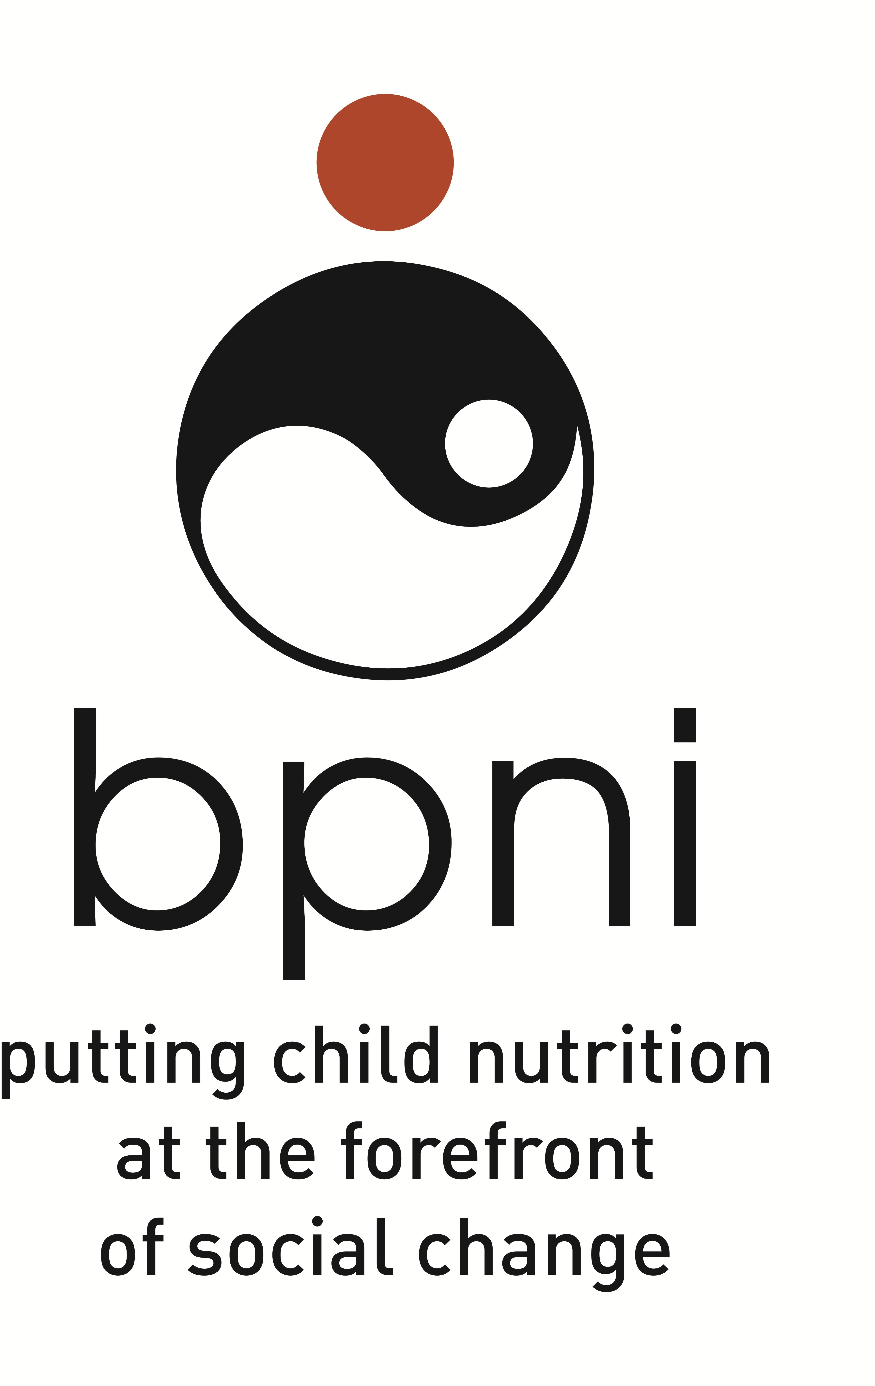

 |  | Others_______________
9. | a. In what conditions infant formula was used in your facility during the last one month? | - Not enough milk  - Infant not satisfied after breastfeeds  - Infant cries often  - No milk comes when mother tries to express  - Infant suffering with Inborn Error od Metabolism like Galactosemia, Phenyl Ketonuria etc.  - Maternal medication (please specify)  - Maternal Illness (please specify)
 | b. What proportion of infants born in your hospital were given infant formula during the last one months in  your facility? | %
 | c. What proportion of infants were given the pre-lacteal feeds e.g. milk, honey, ghutti etc. in your facility in the  last one month? | %
10. | a. Are feeding bottle, teats and  pacifiers used in your facility? | Yes/No
 | b. In what conditions feeding bottle, teats and pacifiers are used?
 | c. Are the lactating mothers counselled in your facility about the risks of feeding bottles, teats and  pacifiers? | Yes/No
11. | What is the policy for rooming in of infants with their mothers in your  facility? | - Normal Vaginal Birth_________________________  - Caesarean Births
12. | Does your facility provide follow-up  support to mothers to sustain breastfeeding? | Yes/No; If yes, provide details about the schedule of follow-up visits

